1. Create new CodeCommit repository

1. Clone the repository using SSH with the following command <git clone ssh://git-codecommit.us-east-1.amazonaws.com/v1/repos/catPipeline-CodeCommit>

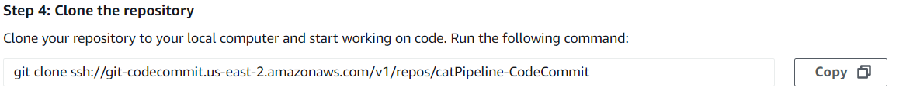

1. Paste some picture content, a Docker file, an image builder, and an Index.html file into the local repository

1. Go to local repository in the CLI. Add the following commands: <git add .>, <git commit -m “container of cats”>, and <git push>

1. Success! Files are now uploaded to repository in AWS, with master branch created.

